**EXPERIMENT-3: Title: DIVIDE AND CONQUER-II**

1. Sort a given set of elements using the Quicksort method and determine the time required to sort the elements. Repeat the experiment for different values of n, the number of elements in the list to be sorted and plot a graph of the time taken versus n. The elements can be read from a file or can be generated using the random number generator**.**

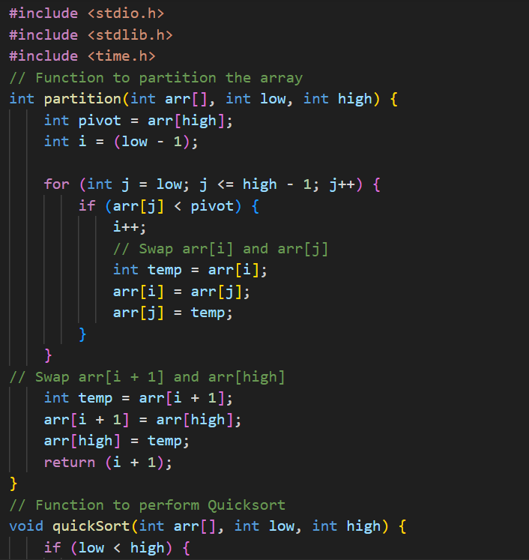

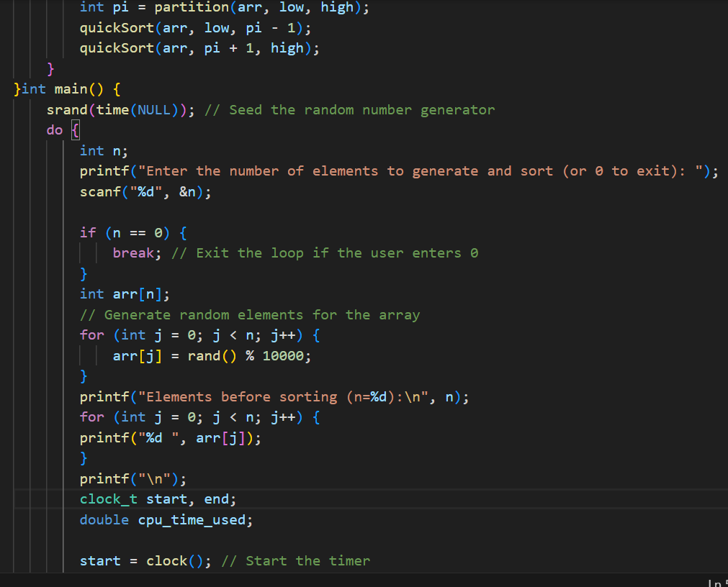

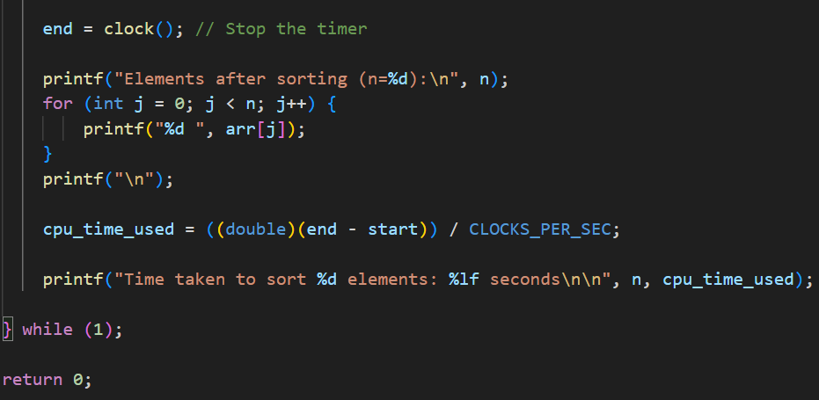

**Output:**

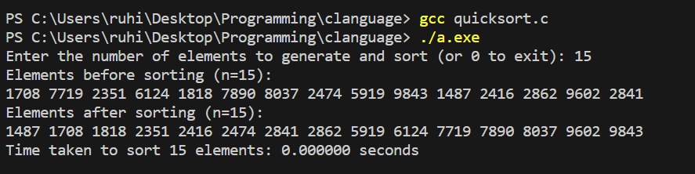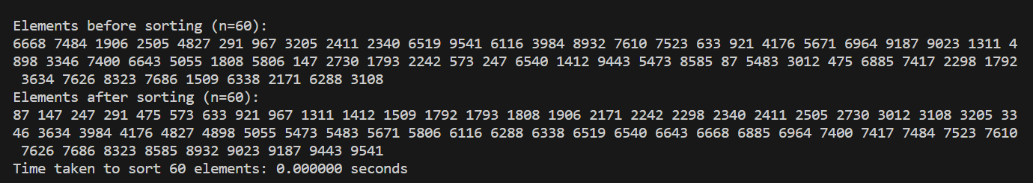

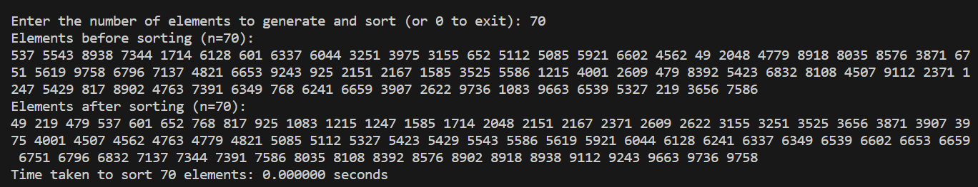

**Graph:**

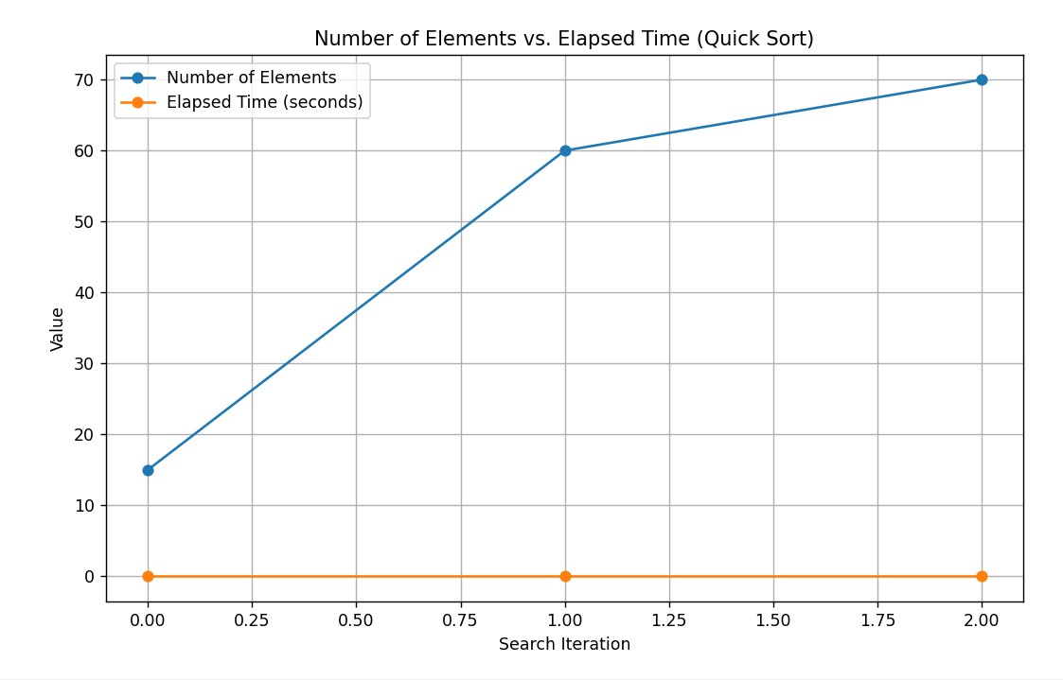

2. Sort a given set of elements using the insertion Sort algorithm to sort a given set of elements and determine the time required to sort the elements. Repeat the experiment for different values of n, the number of elements in the list to be sorted and plot a graph of the time taken versus n. The elements can be read from a file or can be generated using the random number generator.

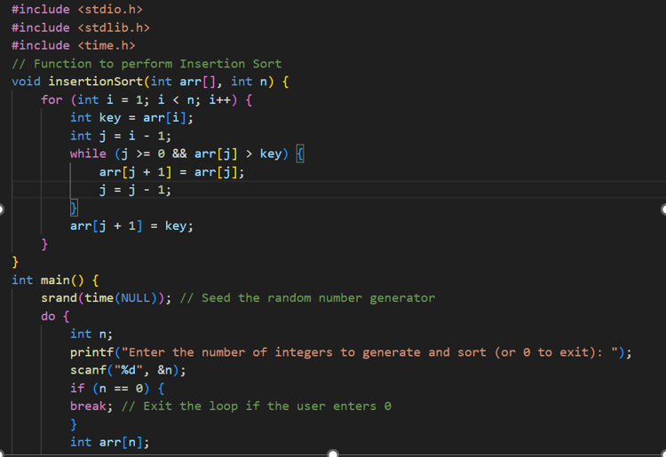

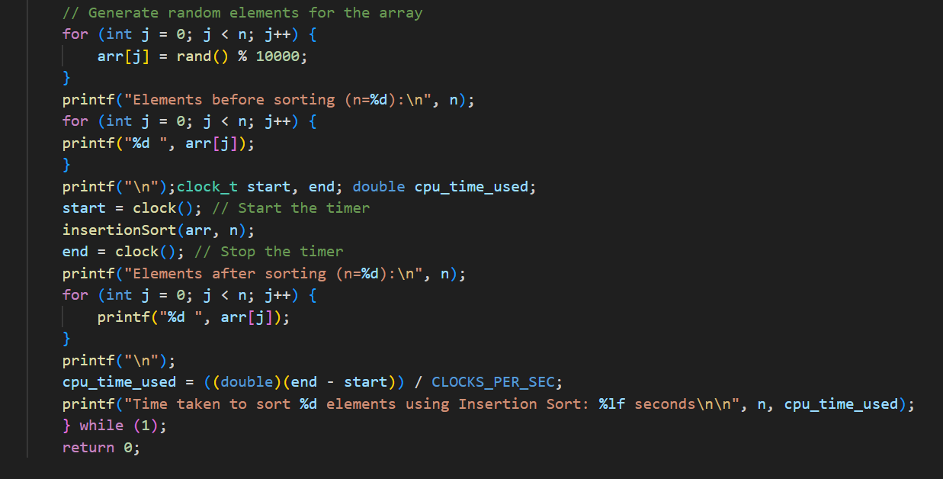

**Output:**

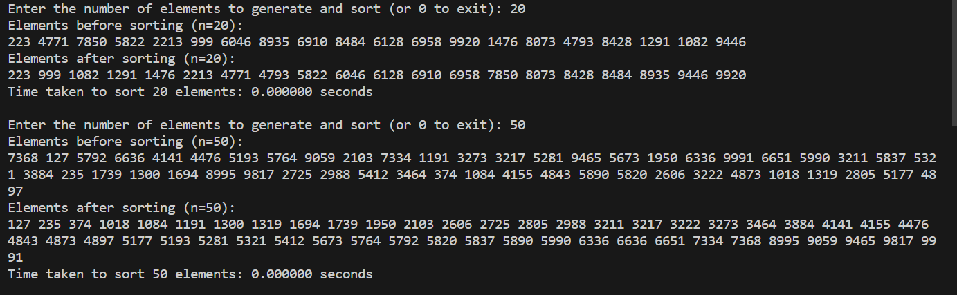

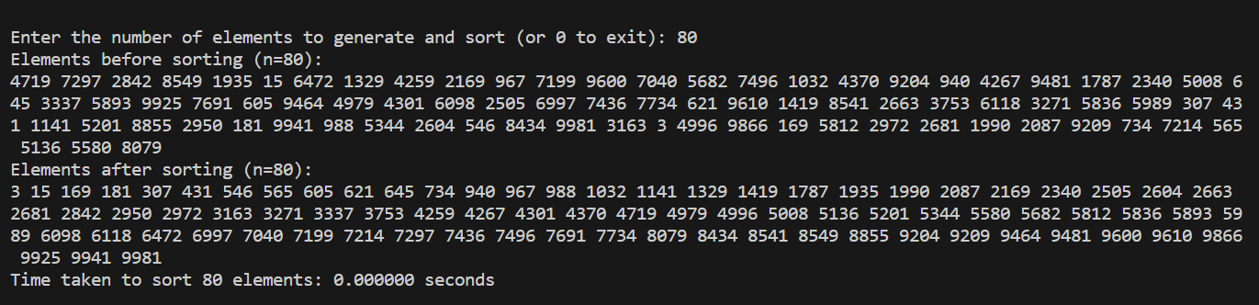

**Graph:**

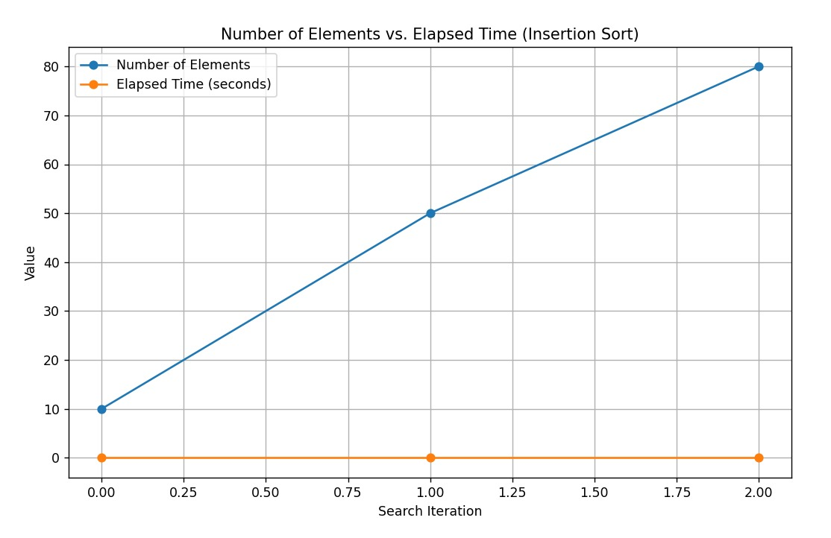

3.Implement Strassen’s matrix multiplication and compare the complexity with normal matrix multiplication.

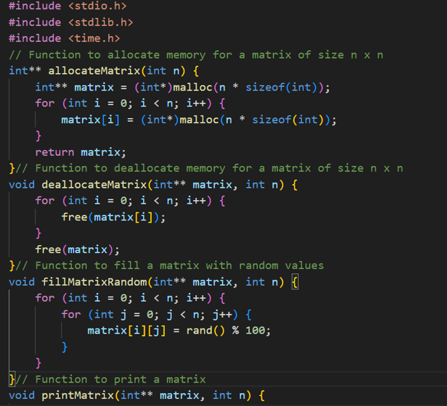

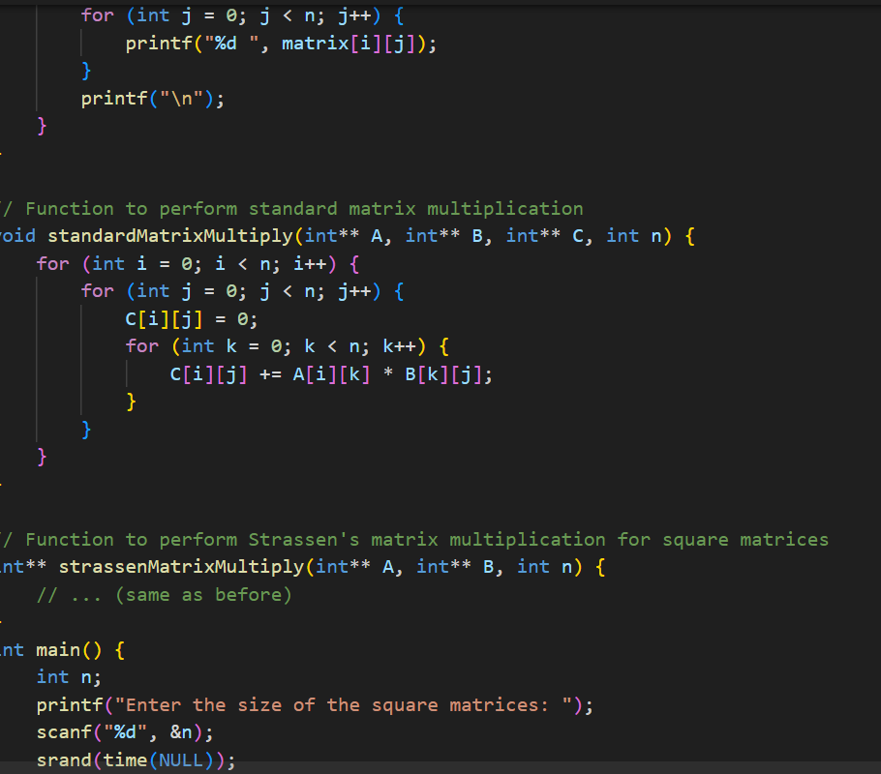

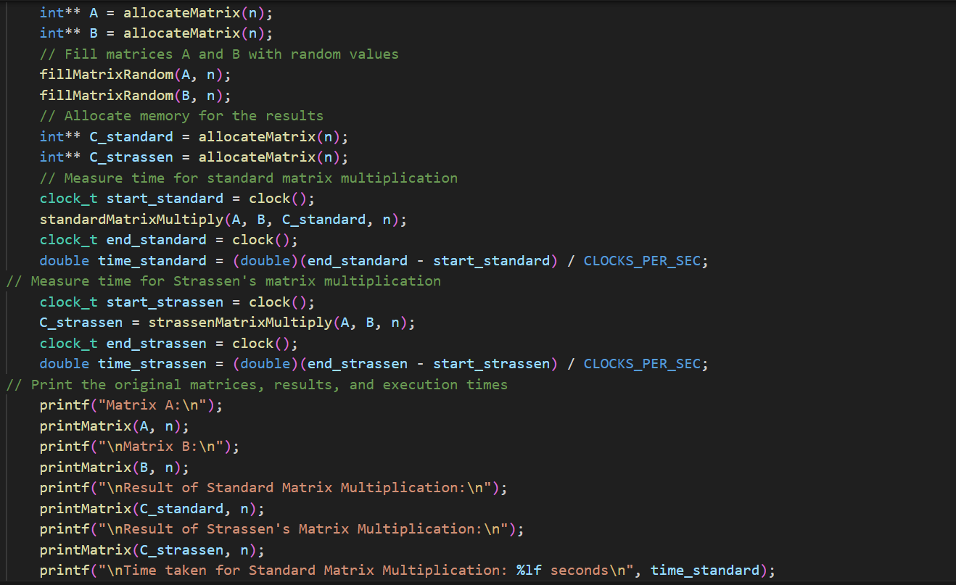



**Output:**

